End of Summer Picnic
PAD/GPCCD
BBQ
KIDS PLAY
Face Painting:
Butterfly, hearts, rainbow, flower, baseball, soccer, football, spider, etc...

Kids Activities:
Water balloons
Bean Bag Toss
Playground
Many more...

Horse Shoes
Poker

Corn hole
Many more….

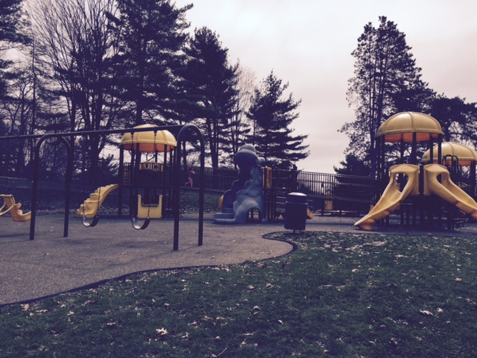
Recreation

Come and Have Fun!

When: SATURDAY, AUGUST 22nd

Time: 11am – Dusk

Lunch: 12 – 1 PM - Cold Cut Sandwiches, Fruit, Veggie Tray, Snacks

Dinner: 4:30 – 6 PM - Hot Dogs, Hamburgers, Side Dishes, Salads

Where: White Oak Park--Maple Shelter

White Oak Park Exd , White Oak Pa 15131

(Access to restroom same location as shelter. BYOB, This is a picnic you do not want to miss)!!!!

Donation: Children under 3: FREE / Children 4-12 years old: $5.00

Adults $10.00

Proceeds will be going to PAD and GPCCD Kids Event Fund
More information, contact: Holly Mendel / Lori Ann LaSorsa Abshier/ Jeff Janaszek
Email: Gpccdkidsevent@gmail.com

Thanks- PAD/GPCCD

