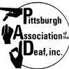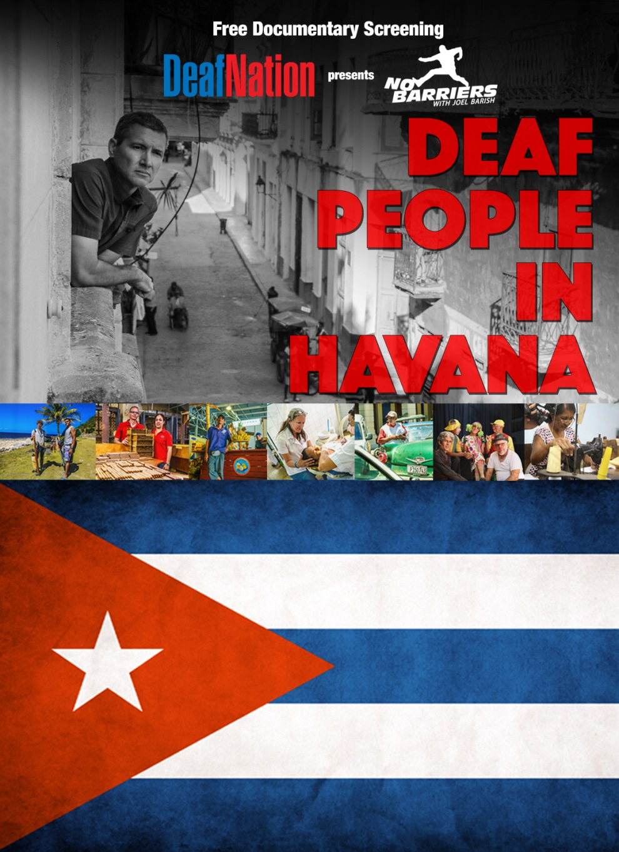

*FREE ADMISSION*

**Hosted By**

**Pittsburgh Association of the Deaf**

Pit

**1854 Forbes Ave, Pittsburgh**

**Donation will be appreciated; all funds will be going to PAD improvement fund.**

**You are welcome to stay after the movie for social with your friends at our club house.**

**Saturday, May 30, 2015**

**Door open at 6pm, movie will begin at 730pm**